## Garlic-Studded Easter Leg Of Lamb

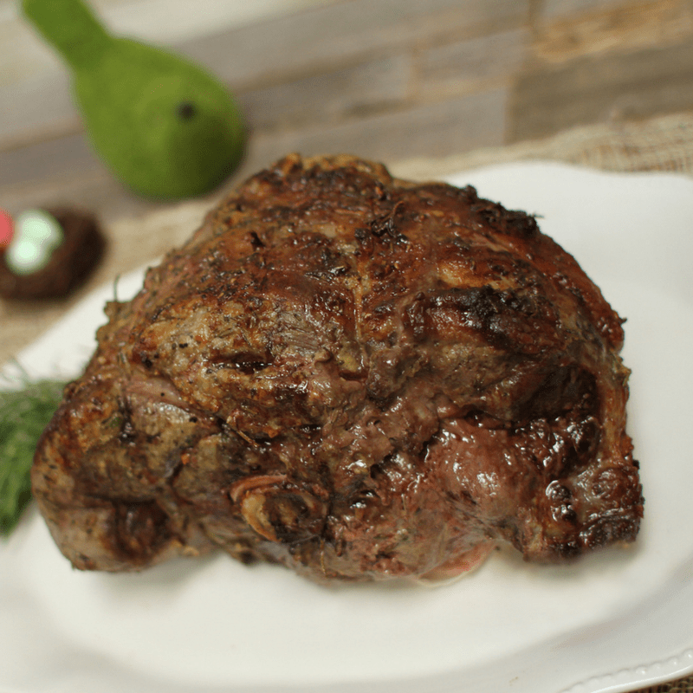

Leg of Lamb is always makes for an elegant Easter meal however, it doesn’t have to be complicated using our Rotisserie Oven. If you’ve never tried garlic-studded Leg of Lamb… here’s your chance! This amazing recipe is literally packed with flavor from the inside-out.  
We used our [**5500 Ronco Rotisserie**](https://www.ronco.com/products/rotisserie-ovens/5500-black-rotisserie.html) to cook this beautiful dinner centerpiece.

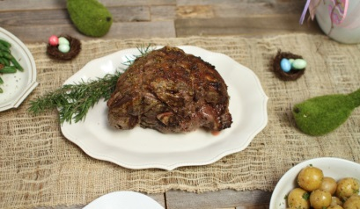

**Ingredients**

* 5 to 7 pound leg of lamb, bone-in shank or bone removed
* 8-10 garlic cloves, cut in half
* sea salt
* fresh cracked mixed peppercorns
* 1 tablespoon plus a splash of olive oil
* splash of aged balsamic vinegar
* 2 tablespoons Dijon mustard
* 2 tablespoons chopped fresh rosemary

**Directions**

1. Using a sharp thin knife, such as our [**boning knife**](https://www.ronco.com/products/kitchen-cutlery.html), pierce your leg of lamb 16-20 times on all sides. Make the slits about an inch deep and wide.
2. Chop 8-10 garlic cloves in half, toss with a splash of good balsamic vinegar, olive oil, pinch of sea salt and some fresh cracked pepper.
3. Slide 1/2 clove seasoned into each slit in lamb.
4. Combine 2 tablespoons chopped rosemary, 1 tablespoon olive oil,  2 tablespoons Dijon mustard in a small bowl, stir to combine.
5. Rub all sides of lamb with rosemary Dijon rub.
6. Truss lamb with 2-3 [**Ronco Rotisserie Ties**](https://www.ronco.com/accessories/rotisserie-ovens.html) to help the lamb cook evenly and hold its shape while cooking.
7. Position lamb onto Rotisserie spits around the center bone.
8. Cook lamb 15-18 minutes per pound for medium temperature. Use a meat thermometer for the most accurate indication of desired doneness. 145°F for medium rare, 160°F for medium and 170°F for well done.
9. Set Rotisserie to ‘no heat’ rotate for 10-15 minutes to allow lamb to rest before carving.